**7. Rapid Prototyping and Risk**

In order to minimize risk, a quick prototype of the system is made. A quick mockup of the system, shown below, is produced to ensure that the project is headed in the right direction and reduce overall risk in the early development phase of the project.

The prototype has also helped us view how the final project will look like and has inspired us to come up with ideas on what a user should expect from a schedule planner in terms of features, layout and ease-of-use.

**7.1 User Interface Mockup**

*7.1.1 Main Layout*

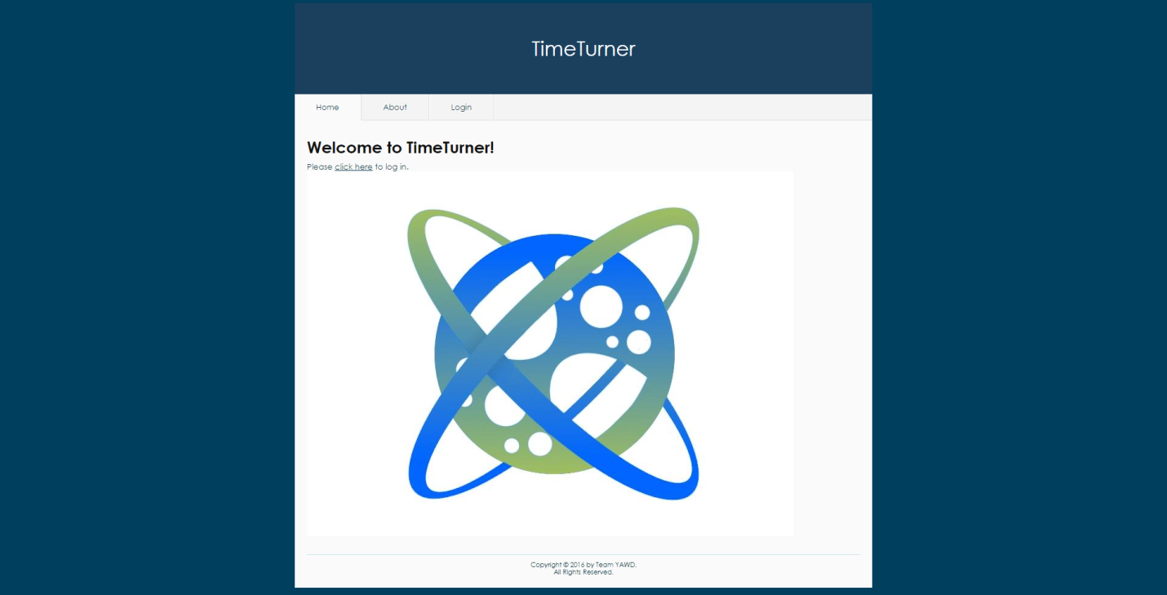

*Figure 1. Main layout of the system*

Upon accessing the TimeTurner website, the user is welcomed with a message and has the choice to login via the tab or by clicking the “click here” link. These will redirect the user to the Login page. The Yii framework was used to generate this layout, as it already contains a few themes.

*7.1.2 Login Interface Mockup*

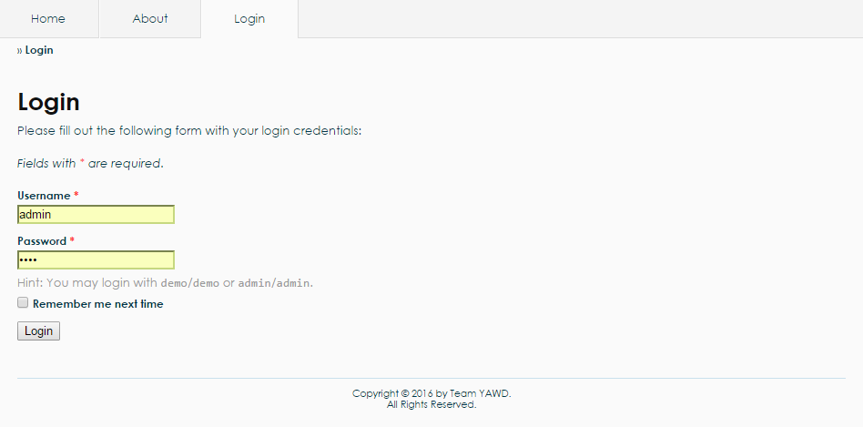

*Figure 2. Login interface mockup*

For the Login interface, there is an authentication form which has been generated by the Yii framework. The user may enter as an admin or as a student. A username and a password are required. Upon clicking the “Login” button, the system will query the database to check if the username and password are valid. The system will redirect to another page if the login is successful, else it will display an error message.

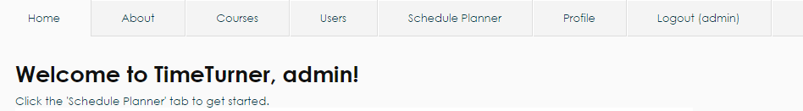

*Figure 3. User menu for an administrator*

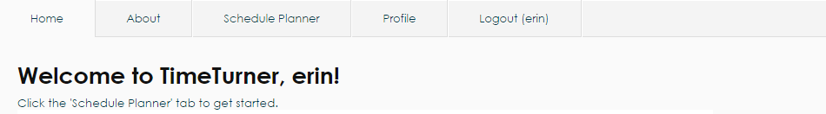

*Figure 4. User menu for a student*

If the administrator logs in, additional tabs appear on top. These are “Courses”, “Users”, “Schedule Planner”, “Profile” as well as a “Logout” tab, as shown in Figure 3. If logged in as a student, the user cannot see the “Courses” and “Users” tabs, as shown in Figure 4, as these can only be modified by the administrator.

*7.1.3 Generate Schedule Interface Mockup*

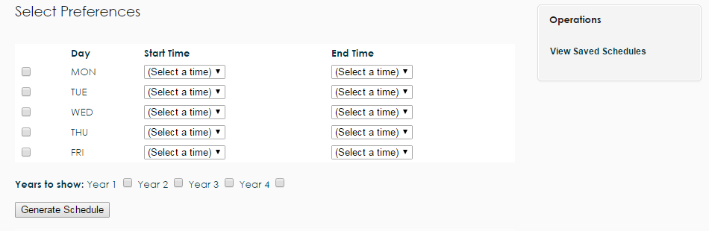

*Figure 5. Generate schedule interface mockup*

All users have a “Schedule Planner” tab, which upon clicking, redirects the user to the page as shown in Figure 5. The user can select their preferences by checking one or more days of the week and select a starting and ending time. The user has the option of choosing which years can be displayed. Additionally, the “Viewed Saved Schedules” operation on the right navigation bar can be selected to view schedules that were previously generated and saved.

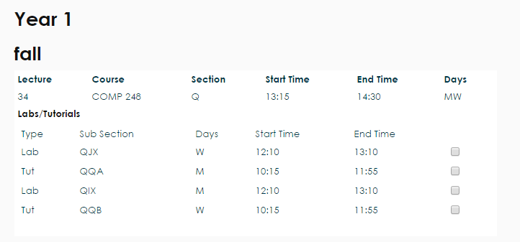

*Figure 6. Classes sections view*

Upon clicking the “Generate Schedule” button, classes are displayed along with their sections, as shown in Figure 6. The user may check the boxes next to the preferred sections.

*7.1.4 Courses and Users Managers Mockup*

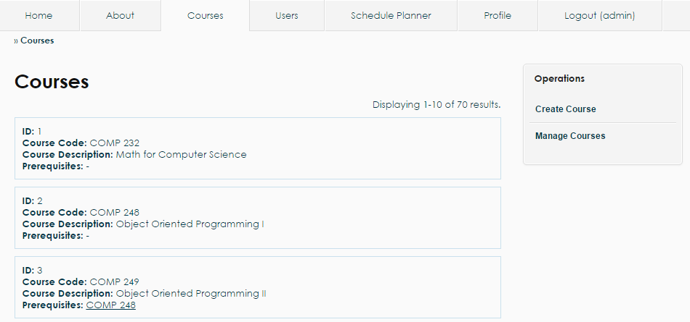

*Figure 7. Courses list view as an administrator*

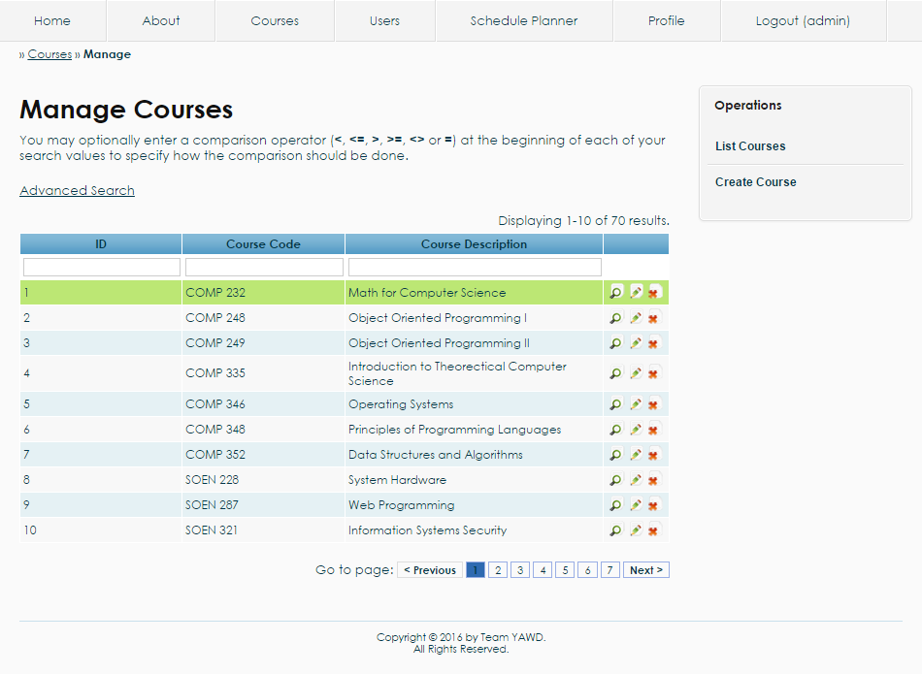

*Figure 8. Courses manager view as an administrator*

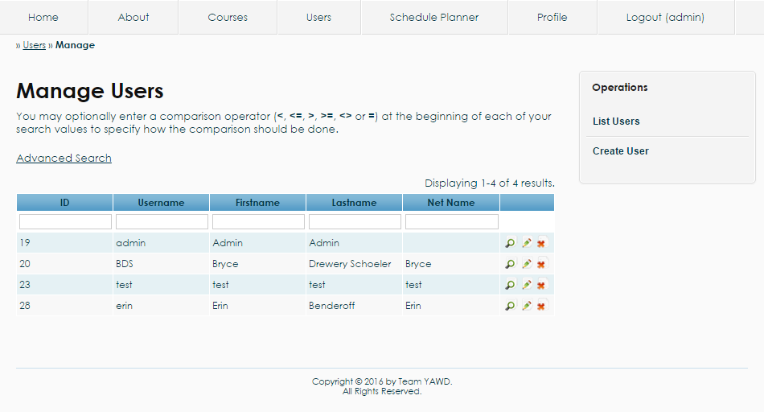

*Figure 9. Users manager view as an administrator*

Logged in as an administrator, the user can manage the courses list as well as the users list. The user has to privilege of modifying an entry or delete it from the database using the tables shown in Figure 8 and Figure 9. On the right navigation bar, there is the operation to “Create User” or “Create Course”, which allows the administrator to add a user or a course directly to the database. The administrator also has the option of listing the courses, which shows the prerequisites for each course, as in Figure 6, as well as listing the users.

**7.2 Risk**

**7.2.1 Framework**

One of the main risks involved in this project is the use of an unfamiliar framework. The current framework in use is Yii, which is based on MVC architecture in PHP. Due to the fact that most of the development team has never worked with a large framework, the learning curve tends to be very high. As such, possible delays might arise during development due to unforeseen problems that might come up while working with Yii. Though one of the major advantages of using this framework, is that it is loaded with features that make development much quicker in the long run; entire modules can be created on the fly with little effort. Depending on the learning curve progress, Yii can either create a healthy environment for development or hurt production.

**7.2.2 Time Constraint**

As deadline approaches, the realization of some features of software will have to be scoped out; only certain core components will be placed in order to meet a good portion of the major requirements of the scheduler.

**7.2.3 Control Version System**

Since the control version system in use is GitHub, the development team opted to use PhpStorm 10, an IDE provided by JetBrains, since it is integrated with Git. This adds up to the learning curve, since the team members have to learn an unfamiliar program, as well as how it works with Git. Using a framework requires working with many files, thus the project needs to be carefully managed. At times, PhpStorm 10 would not synchronize properly with the project’s repository on GitHub, which adds up to the time required to spend on learning and working on other components of the project. Therefore, learning how to properly use Git with PhpStorm can arise in possible delays during development due to team members’ inexperience with them.

**7.2.4 Server Uptime**

During team meetings, the production environment occurs at school. Often times, the network does not work properly as many students and employees try to access Internet at the same time. This would cause a decrease in productive time. Team members also have their own production environment at home. However, if a power outage occurs, the server computer may crash; hindering deployment and causing further delays.